**Experiment – 3**

**Aim:-** Draw the activity diagram for a given problem.

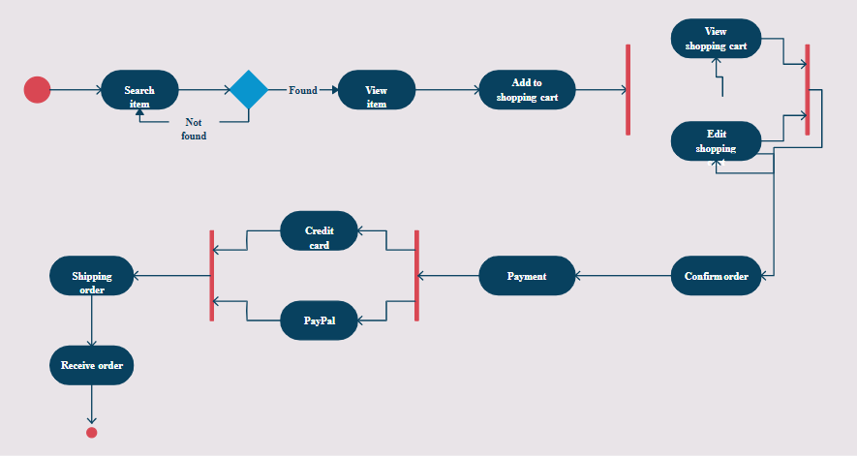

**Experiment:- 4**

**Aim:-** Identify the classes. Classify them as weak and strong classes and draw the class diagram for a given problem.

**Class Diagram:-** Class diagrams describe the static structure of a system, or how it is structured rather than how it behaves.

These diagrams contain the following elements:

**1. Classes,** which represent entities with common characteristics or features. These features includeattributes, operations, and associations.

**2. Associations**, which represent relationships that relate two or more other classes where the relationships have common characteristics or features. These features include attributes and operations.

